SOMERVILLE HOUSE
AUTUMN PRIMARY SCHOOLS
CHESS TEAMS INVITATIONAL 2015

SOMERVILLE HOUSE

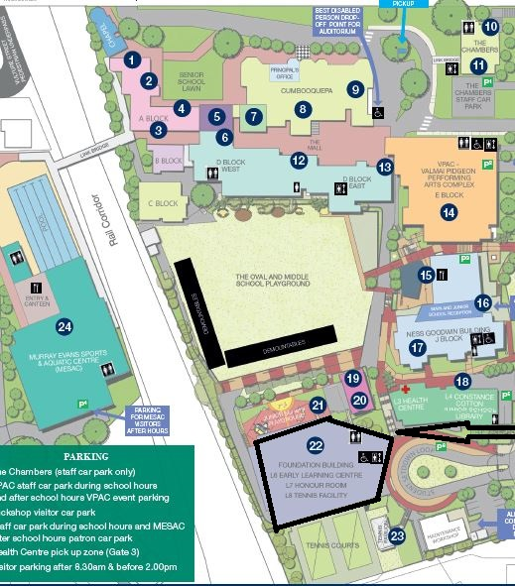
NEW PLAYING VENUE -
PARKING IS AVAILABLE UNDERNEATH THE FOUNDATION BUILDING!
PARKING IS ALSO AVAILABLE IN GRAHAM STREET AND UNDER VPAC.

14 – Valmai Pidgeon Performing Arts Centre (VPAC)
22 – Foundation Building – Chess on Level 7 in Honour Room

ACCESS
- Park in the carpark under the Foundation Building (preferred), and climb stairs to the Honour Room.
- Or park in Graham Street, in the carpark under VPAC, or in the Mater Hospital carpark,
and walk to Foundation Building along Graham Street.

